Zimbabwe

## Political Stability Estimate Data

The data set shows the political stability estimate of the country each year.

## # A tibble: 19 x 5  
## country iso3c date stability stabilityCategory4   
## <chr> <chr> <dbl> <dbl> <chr>   
## 1 Zimbabwe ZWE 1996 -0.464 moderately unstable  
## 2 Zimbabwe ZWE 1998 -0.740 moderately unstable  
## 3 Zimbabwe ZWE 2000 -1.32 highly unstable   
## 4 Zimbabwe ZWE 2002 -1.52 highly unstable   
## 5 Zimbabwe ZWE 2003 -1.09 highly unstable   
## 6 Zimbabwe ZWE 2004 -1.21 highly unstable   
## 7 Zimbabwe ZWE 2005 -1.27 highly unstable   
## 8 Zimbabwe ZWE 2006 -0.933 moderately unstable  
## 9 Zimbabwe ZWE 2007 -1.11 highly unstable   
## 10 Zimbabwe ZWE 2008 -1.21 highly unstable   
## 11 Zimbabwe ZWE 2009 -1.17 highly unstable   
## 12 Zimbabwe ZWE 2010 -1.10 highly unstable   
## 13 Zimbabwe ZWE 2011 -0.945 moderately unstable  
## 14 Zimbabwe ZWE 2012 -0.779 moderately unstable  
## 15 Zimbabwe ZWE 2013 -0.666 moderately unstable  
## 16 Zimbabwe ZWE 2014 -0.714 moderately unstable  
## 17 Zimbabwe ZWE 2015 -0.618 moderately unstable  
## 18 Zimbabwe ZWE 2016 -0.620 moderately unstable  
## 19 Zimbabwe ZWE 2017 -0.774 moderately unstable

## Political Stability Estimate Plot

The plot shows the trends of stabilization and destabilization for the each country.

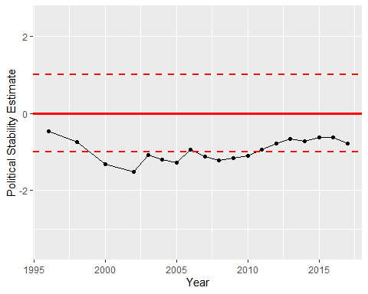

Political Stability Trend